NAfME Collegiate Service Hours
Fall 2020

NAME_________________________ 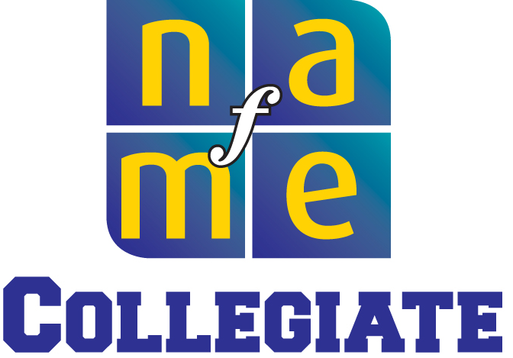

Date Description and Location of Activity Hours Approval Signature

Total Hours:____________________

